#
# At this moment I don’t know where I can tune something, that relay with this question.
#

# SD#1243830
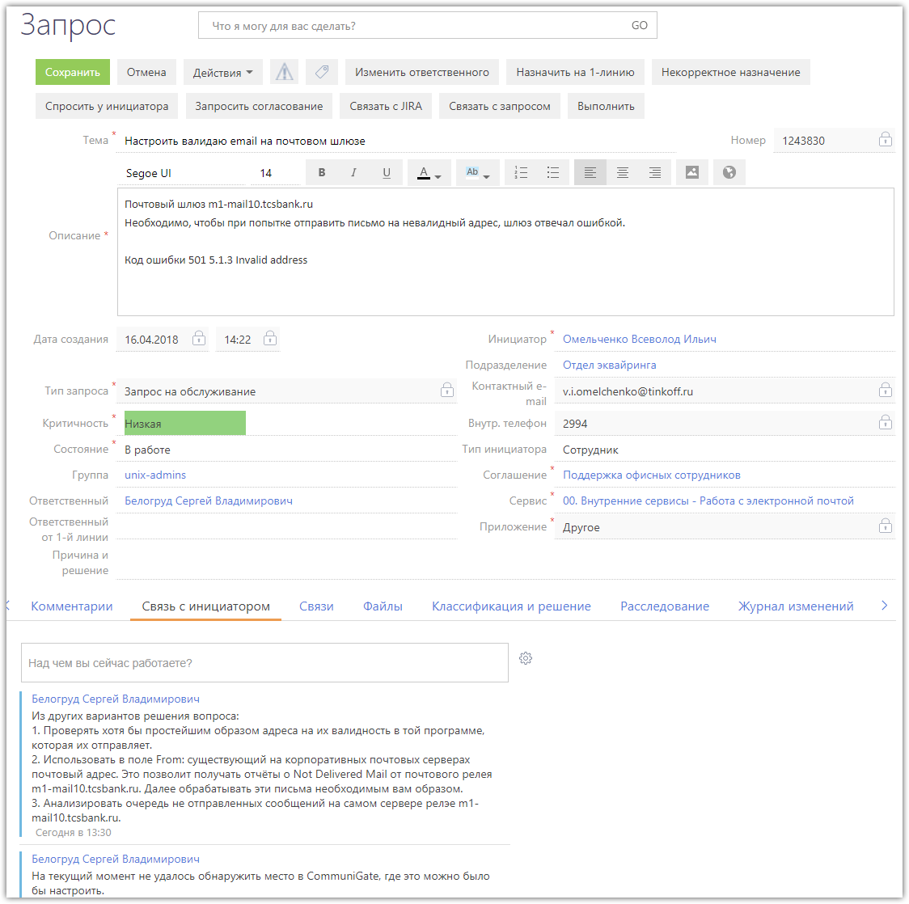

https://sendpulse.com/knowledge-base/smtp/smtp-errors-email-delivery-errors/invalid-email-address-error-codes

Invalid email address error codes

SMTP error 501
Error 501
HTTP 501
501 Not Implemented
HTTP Error 501 Not implemented
The server either does not recognize the request method, or it lacks the ability to fulfil the request.
Command is correct and recognised, but the parameters were invalid. You may receive this error when sending to invalid email addresses or to invalid domain name. Also it may be caused by drops in communication and problems with antivirus settings.

SMTP error 513
SMTP error 501 5.1.3 Invalid address
SMTP error 501 5.1.3 Bad recipient address syntax
Address type is incorrect, there may be typos. You could have copied or pasted an address from a website wrongly. If you have checked all the addresses, and still receive this error, the server needs an authentication.

#
# Something about queue and delayed email.
#

